Course Title | AI Assisted Coding

Name: M. Meghana
Roll Number: 2303A52505
Batch: 50

ASSIGNMENT 5.5
Lab 5: Ethical Foundations – Responsible AI Coding Practices
Lab Objectives:
• To explore the ethical risks associated with AI-generated
Week3 -
code.
• To recognize issues related to security, bias, transparency,
and copyright.
• To reflect on the responsibilities of developers when using
AI tools in software development.
• To promote awareness of best practices for responsible and
ethical AI coding.
Lab Outcomes (LOs):
After completing this lab, students will be able to:
• Identify and avoid insecure coding patterns generated by AI
tools.
• Detect and analyze potential bias or discriminatory logic in
AI-generated outputs.
• Evaluate originality and licensing concerns in reused AI-
generated code.
• Understand the importance of explainability and transparency
in AI-assisted programming.
• Reflect on accountability and the human role in ethical AI
coding practices.
Task Description #1 (Transparency in Algorithm Optimization)
Task: Use AI to generate two solutions for checking prime
numbers:
• Naive approach(basic)
• Optimized approach
Prompt:
“Generate Python code for two prime-checking methods and
explain how the optimized version improves performance.”
Expected Output:
• Code for both methods.
• Transparent explanation of time complexity.
• Comparison highlighting efficiency improvements.

Prompt:
#Generate Python code for two prime-checking methods and explain how the optimized version improves performance

Code:
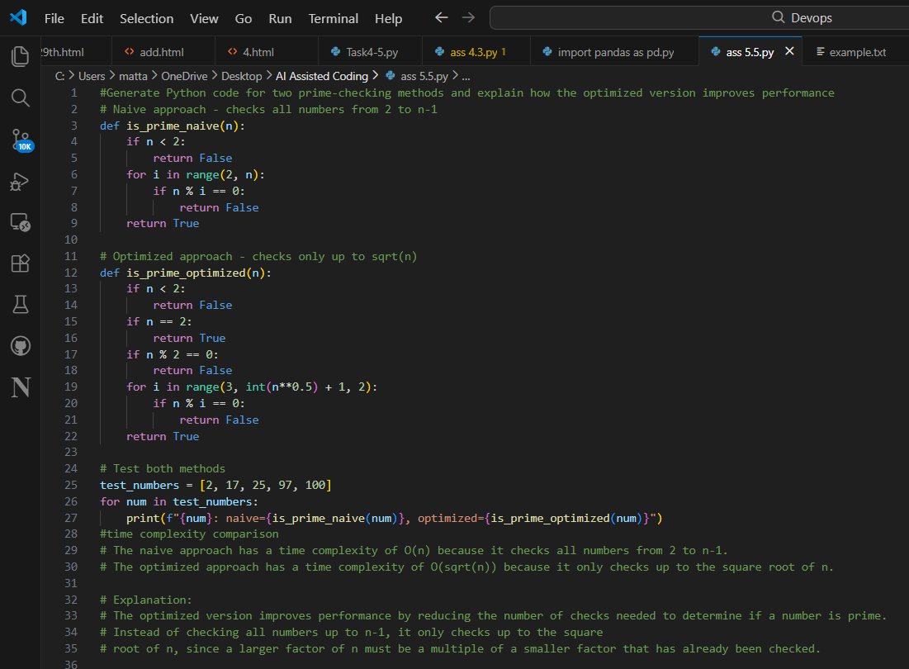
Output:
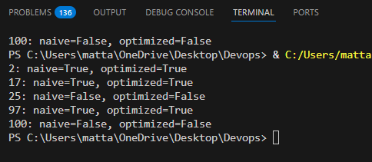
Justification:
The naive prime method checks all numbers up to n, making it slow for large inputs.
The optimized version checks only up to √n, reducing time complexity and improving efficiency.

Task Description #2 (Transparency in Recursive Algorithms)
Objective: Use AI to generate a recursive function to calculate
Fibonacci numbers.
Instructions:
1. Ask AI to add clear comments explaining recursion.
2. Ask AI to explain base cases and recursive calls.
Expected Output:
• Well-commented recursive code.
• Clear explanation of how recursion works.
• Verification that explanation matches actual execution.
Prompt:
#generate a recursive function to calculate fibonacci numbers with clear comments explaining recursion and base cases and recursiive calls

Code:
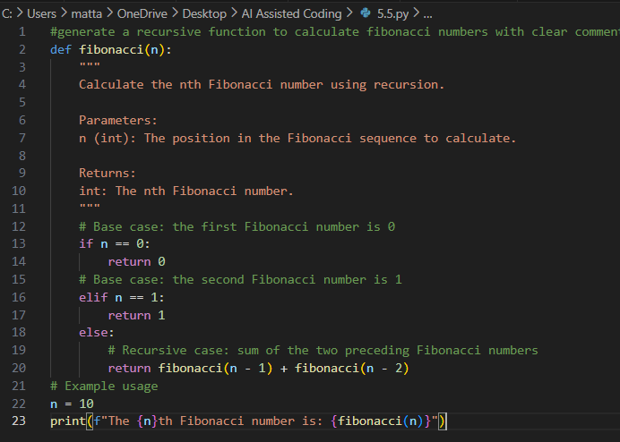
Output:
Justification:
The recursive Fibonacci function works by calling itself until it reaches base cases (0 or 1).
This makes recursion transparent because each call directly matches the mathematical definition.

Task Description #3 (Transparency in Error Handling)
Task: Use AI to generate a Python program that reads a file and
processes data.
Prompt:
“Generate code with proper error handling and clear explanations
for each exception.”
Expected Output:
• Code with meaningful exception handling.
• Clear comments explaining each error scenario.
• Validation that explanations align with runtime behavior.
Prompt:
#Generate code with proper error handling and clear explanations for each exception

Code:
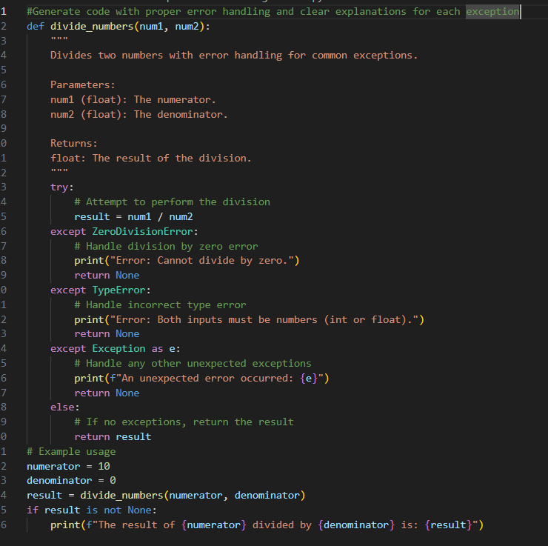
Output:
Justification:
Proper exception handling prevents crashes when files are missing or contain invalid data.
Clear explanations ensure the program behaves safely and predictably during runtime errors.

Task Description #4 (Security in User Authentication)
Task: Use an AI tool to generate a Python-based login system.
Analyze: Check whether the AI uses secure password handling
practices.
Expected Output:
• Identification of security flaws (plain-text passwords, weak
validation).
• Revised version using password hashing and input validation.
• Short note on best practices for secure authentication.
Prompt:
#generate a python based login system with secured password handling

Code:
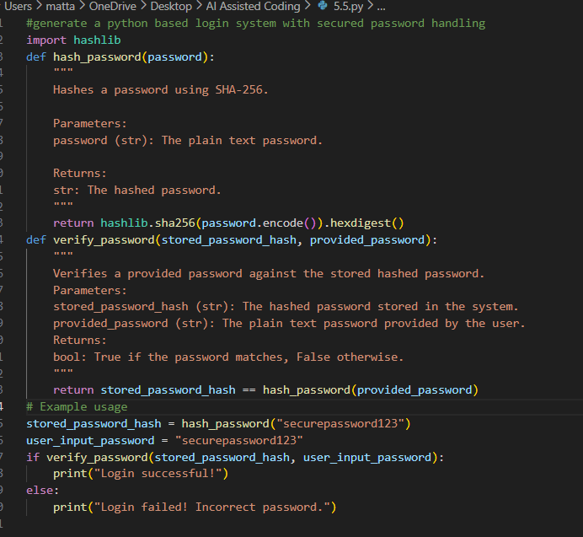
Output:
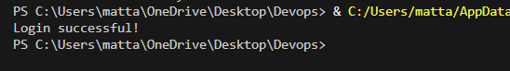
Justification:
Basic login systems may store passwords in plain text, which is insecure.
Using hashing and input validation improves security and protects user credentials.

Task Description #5 (Privacy in Data Logging)
Task: Use an AI tool to generate a Python script that logs user
activity (username, IP address, timestamp).
Analyze: Examine whether sensitive data is logged unnecessarily
or insecurely.
Expected Output:
• Identified privacy risks in logging.
• Improved version with minimal, anonymized, or masked
logging.
• Explanation of privacy-aware logging principles.
Prompt:
#generate a python script that logs users activities with username,IP address timestamps to a log file.Examine

Code:
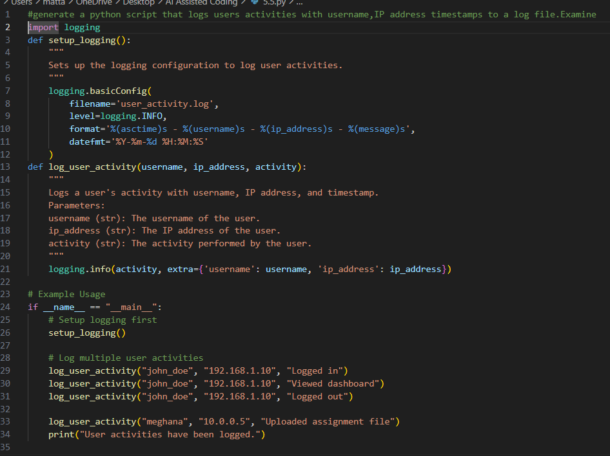
Output:
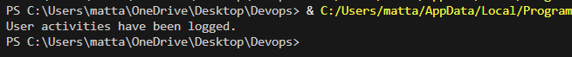
Justification:
Logging sensitive details like full IP addresses can create privacy risks.
Masking or minimizing logged data ensures responsible and privacy-compliant activity tracking.

